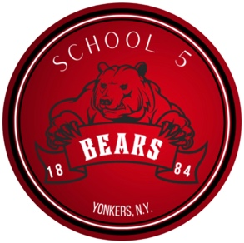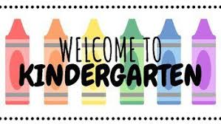

H

August 2023

Dear Kindergarten Families,

I hope you are enjoying the last weeks of summer vacation! I am looking forward to seeing you on the first day of school. Kindergarten is very exciting and I know we will have a year filled with learning, new discoveries and adventures.

Most of the information you will need for the first day is contained in the **“Kindergarten Back to School Folder**” that I will be sending home on the first day of school as well as my School Five teacher web page. Important items to note are:

* 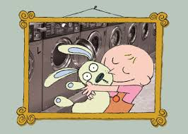**Clothing:** please send in a complete set of seasonal appropriate clothing in a plastic zip lock bag. All clothing and the bag should be labeled.
* **A picture of your child and one of your family**: Please send a 4X6 picture of your child and another picture of your family or you can inbox me pictures on Class Dojo and I can print them out.
* **Snack**: We will have snack in the afternoon. Please include one snack (crackers, pretzels, Goldfish Crackers, animal cookies) and drink (water) in a labeled refillable water bottle. **Snack should be labeled ( __________’s snack).** It is a good idea to start practicing opening up containers, bags, inserting straws into drink pouches, twisting off tops, etc… for lunch time. I encourage using a reusable snack bag and lunch bag in addition to a **refillable labeled water bottle**!
* **Homework Folder**: We will be using a **blue** plastic folder that I will be sending home in a few weeks. This folder is for homework and notes to and from home. Please check the folder nightly and have your child practice placing papers in and out of the folder as well as returning the folder to his/her backpack.
* **Backpack Packing**: Please have your child practice packing and unpacking his/her backpack. Being independent in this task is a big step in Kindergarten! ☺

I can’t wait to welcome you to our class and start what is sure to be a terrific year!

If you have any questions, please feel free to contact me: [jlibrandi@yonkerspublicschools.org](mailto:jlibrandi@yonkerspublicschools.org)

Enjoy the remainder of the summer!

Best,

Ms. Jenn Librandi

